**Project Design Phase-I**

**Solution Architecture**

|  |  |  |  |
| --- | --- | --- | --- |
| |  | | --- | | Date | | |  | | --- | | 19 September 2022 | |
| |  | | --- | | Team ID | | |  | | --- | | PNT2022TMID44843 | |
| |  | | --- | | Project Name | | Airlines Data Analytics for Avaition Industry |
| |  | | --- | | Maximum Marks | | |  | | --- | | 4 Marks | |

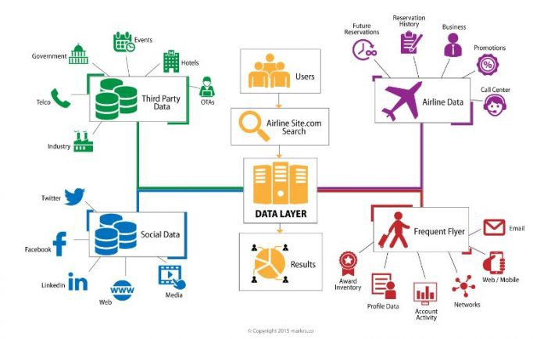

* Search history
* Purchase history
* Checked luggage
* Departure & Arrival date and time
* Destination & Departure city
* In-flight sales/duty free spend
* In-flight food choices
* Hotel, rental car connections
* Number of travelers we fly with
* Credit card points earned
* Miles used
* Our influence over other people through social media